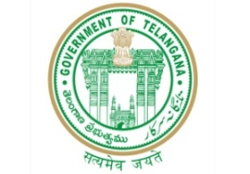**GOVERNMENT OF TELANGANA**

**TELANGANA TRIBAL WELFARE RESIDENTIAL DEGREE COLLEGE (GIRLS), MAHABUBABAD: MAHABUBABAD-DIST**

**https://www.ttwrdcs.ac.in/Mahabubabad**

**E-Mail Id:ttwrdcgirls.mahabubabad@gmail.com Cell No: 7901097695**

**ACADAMIC YEAR 2023-2024**

|  |  |  |  |  |  |  |
| --- | --- | --- | --- | --- | --- | --- |
| S.NO | DEGREE | Semester | Title of the subject | No.of students appeared | No.of students passed | PASS% |
| 1 | UG | III | Statistical methods and Theory of estimation | 9 | 9 | 100% |
| 2 | UG | IV | Statistical Inferences | 9 | 9 | 100% |
| 3 | UG | V | Applied statistics-I | 22 | 22 | 100% |
| 4 | UG | VI | Applied statistics-II | 22 | 22 | 100% |
|  |  |  | TOTAL | 62 | 62 | 100% |